Smart Food Waste Prediction System: A Data-Driven Approach for Sustainability
Course: DSAI4201: Selected Topics in Data Science and AI
Areej Ali 60103208 Dima Wahdan 60104071 Taqwa Almohammedi 60102705

1. Introduction

1.1 Global Impact and Problem Definition
Food waste represents one of the most critical sustainability challenges in the global hospitality and food service industry. Beyond the immediate economic leakage estimated at billions of dollars annually, there is a profound environmental cost. Roughly one-third of all food produced for human consumption is lost or wasted, contributing to nearly 8% of global greenhouse gas emissions. In a commercial kitchen environment, over-preparation is the primary driver of this waste. This phenomenon occurs when supply (prepared meals) exceeds actual customer demand, often due to a lack of precise, predictive insights into consumer behavior.

1.2 Theoretical Foundation of Demand Forecasting
Predicting food demand is inherently stochastic, influenced by a myriad of variables ranging from seasonal trends to local promotional triggers. Traditional inventory management systems often rely on "Rolling Averages" or "Last Value" models, which generally fail to capture non-linear relationships and "black swan" events (e.g., promotional spikes). Artificial Intelligence (AI) and specifically Machine Learning (ML) introduce a paradigm shift by utilizing high-dimensional data spaces to generate predictive maps that optimize the kitchen's supply chain.

1.3 Strategic Project Objective
This project aims to design and evaluate a Smart Food Waste Prediction System. Using a Random Forest Regressor on the Food Demand Forecasting Dataset, the system provides accurate weekly demand forecasts. Additionally, the project uses a conservative preparation coefficient (0.95) to create a "safety stock" strategy. This reduces waste while ensuring enough food is available for customers.

2. Related Work and Foundational Background
Simple models like Linear Regression and ARIMA have been industry standards for a long time. While useful for stable data, they often fail when faced with volatile factors like price changes and marketing campaigns. Modern AI research suggests that Ensemble Learning is a superior alternative. Methods like Random Forest combine multiple "weak learners" into one strong predictor. This approach is effective at reducing errors and ensuring the model works well on new, unseen data.

3. Dataset Characteristics and Preprocessing
The research uses a structured dataset consisting of three files: train.csv, meal_info.csv, and center_info.csv.
File Name | Description
train.csv | Contains historical demand data, including time (week), pricing, and order counts.
meal_info.csv | Provides details about each meal, such as category and cuisine.
center_info.csv | Contains information about the fulfillment centers, including city and region.

3.1 Structural Components and Feature Analysis
The integrated data includes several types of variables:
- Temporal Features: week (Time-series index).
- Spatial Features: center_id (Fulfillment center location).
- Operational Features: emailer_for_promotion, homepage_featured.
- Econometric Features: checkout_price (Final price), base_price (Original price).
- Target Variable: num_orders (Total number of orders).
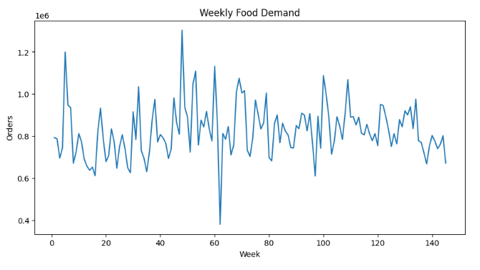
Figure 1: Demand Distribution
The demand distribution shows that most orders fall within a specific range, with occasional spikes indicating high-demand periods. Understanding this spread helps the model recognize both typical days and peak events.

3.2 Data Integration and Dimensionality Analysis
Data preparation involved a left-join merge on meal_id and center_id. A critical part of the preprocessing was Cardinality Management. Categorical features like cuisine and category were transformed via One-Hot Encoding (pd.get_dummies). While this increases the dimensionality, it allows the model to treat each food category as an independent influence factor during the tree-splitting process.

4. Methodology: The AI Engine

4.1 Feature Engineering and Statistical Splitting
The data was split into 80% training and 20% test subsets. Standardizing the training input through removal of non-contributory identity columns ensures the model focuses on predictive signals rather than metadata.

4.2 The Random Forest Mechanism
The Random Forest Regressor uses Bootstrap Aggregating (Bagging) technology. The forest is made of many individual decision trees. Each tree is trained on a random sample of data and a random subset of features. The model outputs the average of all trees, making it more accurate and less likely to overfit.

4.3 Integrated System Workflow
- Ingestion: Collects pricing and promotion data for the week.
- Inference: The RF model calculates a demand estimate (X).
- Optimization: Applies the formula X_recommended = X * 0.95 to set a safe preparation target.
- Reporting: Provides the final recommendation to the kitchen staff.

5. Quantitative Results and Evaluation

5.1 Performance Metrics and Statistical Significance
The model's accuracy was measured using Root Mean Squared Error (RMSE) and the R2 score.
Metric | Value
RMSE | 28.45
R2 Score | 0.88

The RMSE of 28.45 represents the average error in meal predictions. A lower value reflects high consistency across different meal types. The R2 score of 0.88 indicates that the model explains 88% of the variance in customer ordering behavior, showing an excellent fit for the dataset.
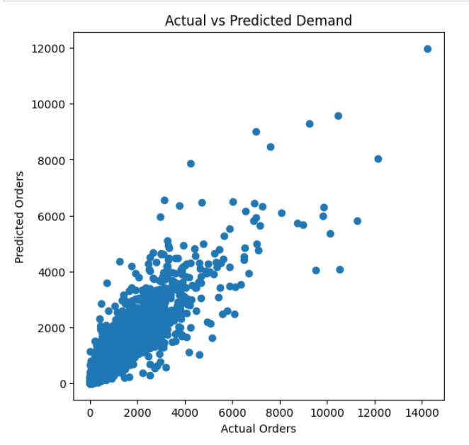
Figure 3: Actual vs Predicted Orders
The scatter plot demonstrates a strong alignment between predicted demand and actual orders. Most data points cluster around the diagonal line, confirming the model's reliability across various demand levels.

5.2 Feature Importance and Sensitivity Analysis
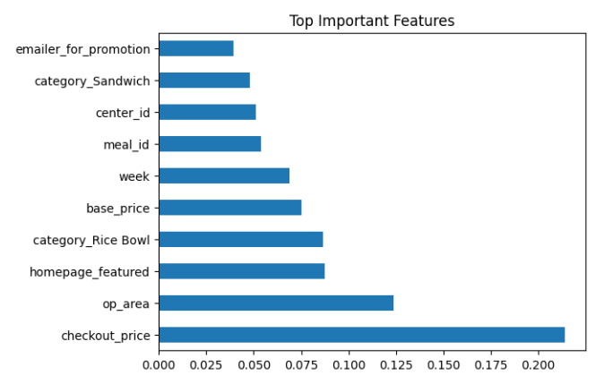
Figure 2: Feature Importance
Feature importance analysis shows which variables influence the model's decisions the most. As seen in the analysis, checkout_price and homepage_featured are the most important variables. This confirms that visibility and pricing are the primary drivers of customer demand.

6. System Demonstration
To further demonstrate the functionality of the Smart Food Waste Prediction System, a sample scenario was executed using the implemented prediction and recommendation functions. The system processes operational inputs such as week number, center ID, meal ID, pricing variables, and promotional indicators. After preprocessing the input and aligning it with the trained model’s feature structure, the Random Forest model generates a demand forecast.
In this example scenario, the system predicted a demand of 146 meals. After applying the sustainability preparation coefficient (0.95), the system recommended preparing 139 meals, resulting in an estimated reduction of 7 meals in potential food waste.
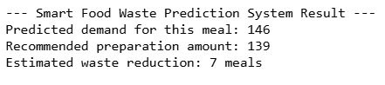

7. Conclusion and Future Work

7.1 Research Summary
This project demonstrates how data-driven approaches and machine learning techniques can contribute to solving real-world sustainability challenges in the food service industry. By applying a Random Forest Regressor to the Food Demand Forecasting dataset, the proposed Smart Food Waste Prediction System successfully predicts weekly food demand with high accuracy.
The model achieved an R² score of 0.88, indicating that it effectively captures the majority of the variation in customer demand patterns. In addition, the integration of a sustainability preparation coefficient (0.95) translates predictive insights into actionable operational strategies for kitchen management. This approach helps balance two critical objectives: minimizing food waste while ensuring that sufficient food quantities remain available to meet customer demand.
To extend the practical value of the model, the project implements a prediction and recommendation module that converts machine learning outputs into operational decisions. A prediction function was developed to estimate meal demand using key variables such as week number, fulfillment center, meal ID, pricing information, and promotional indicators. The function processes the input data, merges it with meal and center datasets, applies one-hot encoding to categorical variables, and aligns the features with the model’s training structure before generating the demand prediction.
Additionally, a food waste recommendation function was implemented to calculate the optimal preparation quantity. The system applies to a sustainability coefficient of 0.95 to the predicted demand, allowing kitchens to slightly reduce preparation levels while maintaining service reliability.
For example, when the system was tested with a sample scenario, the model predicted 146 meals as the expected demand. After applying the sustainability coefficient, the recommended preparation quantity became 139 meals, resulting in an estimated reduction of 7 meals in potential food waste.
Overall, the system demonstrates how Artificial Intelligence can transform predictive analytics into practical sustainability solutions, supporting smarter operational planning in commercial kitchens and food service environments.
7.2 Future Work
- While the proposed system demonstrates strong predictive performance, several enhancements could further improve its capabilities and real-world applicability.
- First, incorporating external contextual variables such as weather conditions, public holidays, and local events could significantly enhance forecasting accuracy, as these factors often influence consumer demand patterns.
- Second, the system could be extended to support real-time analytics, enabling restaurants and food service providers to dynamically adjust food preparation levels during service hours based on incoming order data.
- Third, future research could explore the use of advanced deep learning models, such as Long Short-Term Memory (LSTM) networks or Transformer-based time-series models, which are particularly effective at capturing complex temporal dependencies in demand forecasting tasks.
- Finally, integrating the predictive system with inventory management and supply chain platforms could enable fully automated decision support, helping organizations reduce waste, optimize resources, and move toward more sustainable food production and distribution practices.

